Translating Bacterial Population Genomics into Infection Dynamics: A Mechanistic Systems Biology ODE Model of Sepsis caused by Klebsiella pneumoniae
Authors: Gautham G L1, Dhruti Reddy P1, S Apurva Ananya1, Sasmita Sabat1,*
Affiliations: 1 Department of Biotechnology and Systems Biology, National Institute of Technology, India.
* Corresponding author. Target Journal: OMICS: A Journal of Integrative Biology (Editor-in-Chief: Dr. Biaoyang Lin, PhD).
Abstract
The clinical severity of Gram-negative sepsis is governed by nonlinear interactions between bacterial virulence and host immunity. While microbial genome-wide association studies (mGWAS) identify accessory genes linked to bacteremia, static effect sizes cannot predict longitudinal infection trajectories, cytokine storm kinetics, or time-dependent therapeutic responses. To bridge this divide, we present an integrative systems biology framework translating bacterial population genomics into a mechanistic ordinary differential equation (ODE) model of Klebsiella pneumoniae sepsis. Using pyseer linear mixed models across 200 genomes (100 sepsis blood isolates, 100 non-sepsis controls), we identified three orthogonal determinants of invasiveness: the clpK/clpB chaperone operon (beta = +0.434), the egtB ergothioneine pathway (beta = +0.394), and bla_1/IS6 elements (beta = +0.350). These effect sizes were mapped as rate multipliers into an extended 10-compartment ODE system capturing neutrophils, macrophages, cytokines (IL-6, TNF-alpha, IL-10), tissue damage, antibiotic pharmacokinetics/pharmacodynamics, and lipopolysaccharide (LPS) kinetics. Global sensitivity analysis (N = 1,000) confirmed that pyseer multipliers are primary drivers of organ damage. Simulations reveal that while single virulence genes cause self-limiting inflammation, their combination exhibits epistatic synergy, driving tissue injury past an irreversible tipping point (D > 0.36) into fatal septic shock. Antibiotic administration at 6.0 hours halts damage progression (Peak D = 0.281 for ceftriaxone, 0.293 for meropenem vs. 1.500 untreated), sterilizes bacteremia, and curtails cytokine exposure by over 50%. Rapid meropenem bacteriolysis triggers a transient +74% endotoxin burst (0.040 at 7.5 hours), explaining post-antibiotic inflammatory flares. Delay titration reveals a strict 10-hour Golden Window, beyond which microbial clearance fails to avert fatal collapse.
Keywords: Klebsiella pneumoniae; Microbial OMICs; Pangenome-Wide Association (mGWAS); Systems Biology; Ordinary Differential Equations (ODE); Endotoxin (LPS); Pharmacogenomics; Sepsis; Cytokine Storm; Golden Window; Theranostics.
1 Introduction
Sepsis is a life-threatening organ dysfunction caused by a dysregulated host response to infection, representing a global healthcare crisis responsible for an estimated 48.9 million cases and 11.0 million deaths annually [1]. Gram-negative bacilli are the predominant causes of hospital-acquired bloodstream infections, among which Klebsiella pneumoniae is of exceptional concern due to the rapid emergence of multidrug-resistant (MDR) and hypervirulent lineages [2]. In intensive care units, bacteremia caused by K. pneumoniae exhibits divergent clinical trajectories: some patients clear the infection with transient inflammation, whereas others rapidly deteriorate into septic shock, refractory hypotension, and fatal multi-organ failure [1,2]. Understanding the biological determinants governing this bifurcation is essential for improving clinical management.
Microbial genome-wide association studies (mGWAS) using linear mixed models (LMMs), such as pyseer, have enabled high-throughput mapping of accessory genes, plasmids, and resistance mutations linked to invasive phenotypes while correcting for clonal population stratification [8,10]. However, a fundamental limitation separates statistical genomics from clinical pathophysiology. Static GWAS effect sizes (log-odds ratios, β) cannot capture the temporal kinetics of host-pathogen interactions, the nonlinear progression of cytokine storms, or the dynamic impact of antibiotic administration. Statistical associations yield static risk factors, but clinical sepsis is fundamentally a dynamic disease.
Mathematical modeling using ordinary differential equations (ODEs) provides an established framework for simulating acute inflammation. Pioneering ODE models by Reynolds et al. [3], Chow et al. [4], and Kumar et al. [15] demonstrated that sepsis progression can be understood as a dynamical transition across a bistable manifold separating healthy resolution from an irreversible damage attractor driven by damage-associated molecular patterns (DAMPs). Nevertheless, existing ODE models have historically treated bacterial pathogens as generic variables governed by phenomenological constants, lacking connection to the pathogen's specific genomic architecture and virulence repertoire [3-5].
In alignment with the trans-disciplinary mission of OMICS: A Journal of Integrative Biology, which emphasizes systems-level integration from cell to society, this study presents a computational framework that translates bacterial population genomics into infection dynamics. We performed baseline and conditional pyseer mGWAS on 200 clinical K. pneumoniae genomes, identified orthogonal determinants of invasiveness, and mapped these effect sizes into an extended 10-compartment ODE model. This model incorporates neutrophils, macrophages, cytokine cascades (IL-6, TNF-α, IL-10), tissue damage (D), two-compartment pharmacokinetics/pharmacodynamics (ceftriaxone, meropenem), and lipopolysaccharide (LPS/endotoxin) release kinetics. Through Latin Hypercube Sampling sensitivity analysis, mapping robustness testing, and treatment delay titration, we characterize the bacteriolytic endotoxin burst and delineate the clinical 'Golden Window' of antimicrobial therapy.
2 Methodology
2.1 WGS Study Design, Pangenome Clustering, and Data Standards
Raw whole-genome short-read sequencing data (Illumina platform) from 100 Klebsiella pneumoniae isolates recovered from positive blood cultures of hospitalized sepsis patients were retrieved from the NCBI Sequence Read Archive (SRA) using fasterq-dump. A matching control cohort of 100 non-invasive/non-sepsis K. pneumoniae isolates was retrieved from the NCBI Assembly database in FASTA format. Quality assessment was conducted using FastQC (v0.11.9) [49]. Adapter trimming and quality filtering were executed with fastp (v0.23.2) [50], and assembly was performed using MEGAHIT (v1.2.9) [51]. Assembly metrics were benchmarked with QUAST (v5.2.0) [52], confirming N50 > 20 kbp and genome sizes of 5.3–5.5 Mbp.
Antimicrobial resistance genes were profiled using NCBI AMRFinderPlus (v3.11.26) [53]. Capsular (K-locus) and lipopolysaccharide (O-locus) serotypes were determined with Kleborate (v2.4.1) via Kaptive [54]. Functional annotation was performed with Prokka (v1.14.6) [55], and pangenome clustering was conducted with Panaroo (v1.3.4) in strict mode [56], yielding 16,477 gene clusters presented as a presence/absence matrix (Rtab). All metadata and sequence accessions comply with OMICS data standards.
2.2 Microbial Genome-Wide Association Analysis (mGWAS)
2.2.1 Cohort Sample Size Justification and Power Analysis
A sample size of 200 isolates (100 sepsis, 100 controls) was established based on clinically curated WGS datasets. To evaluate statistical power, we applied benchmarks established by Saber & Shapiro [48]. In bacterial association studies using linear mixed models (LMMs), statistical power depends on effect size (β), minor allele frequency (MAF), and population structure. Saber & Shapiro demonstrated that for intermediate allele frequencies (MAF 5%–95%), an LMM-based bacterial GWAS achieves >80% power to detect moderate-to-large gene effect sizes (β ≥ 0.30) with cohorts of N = 100 per arm [48]. Because nosocomial bacteremia in K. pneumoniae is driven by major fitness and resistance clusters rather than infinitesimal polygenic variations, our cohort possesses robust power to identify true determinants of invasiveness while controlling type I error under Bonferroni correction.
2.2.2 Estimation of Population Structure and Kinship Correction
Bacterial populations exhibit strong clonal structure requiring correction to prevent lineage markers from appearing as spurious associations [10,13]. Pairwise whole-genome distances were computed using MASH (v2.3, k = 21, s = 10,000) [9] and inverted into a 200 × 200 kinship similarity matrix: Similarity = 1 − (distance / max_distance). The MASH kinship matrix yielded an estimated heritability of h² = 0.90, effectively conditioning out clonal background while permitting gene-level effect size estimation [10].
2.2.3 Baseline mGWAS and Justification of Clonal Genomic Inflation
Baseline association testing was performed using the LMM in pyseer (v1.4) [8], evaluating 3,735 filtered gene clusters (MAF 5%–95%) against the binary sepsis phenotype. Significance was established under Bonferroni correction (p < 0.05 / 3,735 = 1.34 × 10⁻⁵) [11], yielding h² = 0.90 and a genomic inflation factor of λ = 1.531 [12]. In bacterial GWAS, elevated λ values (1.4–2.0) are expected due to pervasive linkage disequilibrium along clonal lineages, as documented by Power et al. [13] and Earle et al. [10]. Conditional testing reduced λ to 1.460, and all identified loci were subsequently validated through mechanistic integration into our ODE model.
2.2.4 Conditional mGWAS for Secondary Signal Discovery
To detect independent accessory signals masked by primary loci, conditional association testing was conducted by including the presence/absence vectors of Bonferroni-significant baseline genes as fixed-effect covariates in the pyseer LMM, identifying secondary epistatic loci.
2.3 Mathematical Model Architecture: Extended 10-Compartment ODE System
We extended the acute inflammation models of Reynolds et al. [3] and Kumar et al. [15] into a 10-compartment system comprising: normalized bacterial burden (B), activated neutrophils (N), activated macrophages (M), interleukin-6 (IL-6), tumor necrosis factor-alpha (TNF-α), interleukin-10 (IL-10), cumulative tissue damage index (D), antibiotic depot (A_dep), antibiotic plasma concentration (A_p), and free circulating lipopolysaccharide (LPS, L).
2.3.1 Bacterial Dynamics and Virulence Multipliers
Bacterial replication follows logistic growth with replication rate k_b = 0.45 h⁻¹, natural clearance d_b = 0.12 h⁻¹, and immune surveillance k_surv = 0.05 h⁻¹. Systemic killing is executed by activated neutrophils (N_act = N − N_0) and macrophages (M_act = M − M_0), modulated by IL-10 immunosuppression (supp = 1 / (1 + κ_IL10 · IL10)) and Hill antibiotic killing (E_abx):
dB/dt = k_b · B · (1 − B) − d_b · B − k_surv · B − [(k_NB,ox / φ_ROS) · N_act · B · supp] − [k_NB,pep · N_act · B · supp] − [(k_MB / φ_stress) · M_act · B · supp] − E_abx · B
where φ_ROS and φ_stress represent pyseer-derived multipliers for oxidative stress evasion (egtB) and proteotoxic disaggregation (clpK/clpB).
2.3.2 Innate Immune Cell Pools (Neutrophils and Macrophages)
Resting neutrophils (N_0 = 1.0) and macrophages (M_0 = 1.0) are recruited and activated by bacteria, free endotoxin, and cytokine signaling:
dN/dt = [(k_N,rec · B + k_N,LPS · L + k_N,cyt · (IL6 + TNF)) · supp] − d_N · (N − N_0)
dM/dt = [(k_M,bact · B + k_M,LPS · L + k_M,cyt · (IL6 + TNF)) · supp] − d_M · (M − M_0)
2.3.3 Cytokine Network and CARS Kinetics
Pro-inflammatory cytokines IL-6 and TNF-α are secreted by activated leukocytes upon stimulation by bacteria and free endotoxin. Interleukin-10 (IL-10) models the Compensatory Anti-inflammatory Response Syndrome (CARS):
dIL6/dt = [((k_IL6,N · N + k_IL6,M · M) · B + k_IL6,LPS · M · L) · supp] − d_IL6 · IL6
dTNF/dt = [(k_TNF,M · M · B + k_TNF,LPS · M · L) · supp] − d_TNF · TNF
dIL10/dt = [k_IL10,M · (M − M_0) + k_IL10,cyt · (IL6 + TNF) + k_IL10,LPS · L] − d_IL10 · IL10
2.3.4 Tissue Damage Index and Consensus Sepsis Threshold
The cumulative tissue damage index (D) reflects cellular injury and DAMP signaling (HMGB1, mtDNA), driven by bacterial toxicity, cytokine collateral damage, direct endotoxin microvascular injury, and quadratic self-amplification representing decompensating organ failure:
dD/dt = [k_D,bact · B + k_D,cyt · (IL6 + TNF) + k_D,LPS · L + k_D,comp · D²] − d_D · D
A consensus sepsis threshold is defined at D = 0.36. Below D = 0.36, the system recovers to baseline. Above D = 0.36, the quadratic term (k_D,comp · D²) dominates over tissue repair (d_D · D), pulling the trajectory into an irreversible organ failure attractor (D → 1.500), consistent with Sepsis-3 criteria [1].
2.3.5 Pharmacokinetics and Pharmacodynamics (Ceftriaxone and Meropenem)
Antibiotic dosing is modeled using a two-compartment PK model (dA_dep/dt = −k_a · A_dep; dA_p/dt = k_a · A_dep · F − k_el · A_p). Ceftriaxone was parameterized with 60 mg/L IV q24h (k_el = 0.087 h⁻¹, t_1/2 ≈ 8 h) [18]. Meropenem was parameterized with 40 mg/L IV q8h (k_el = 0.69 h⁻¹, t_1/2 ≈ 1 h) [19]. Antibiotic killing follows an E_max Hill function where effective concentration is scaled by the resistance multiplier φ_abx: A_eff = A_p / φ_abx (E_abx = E_max · A_eff^h / [EC50^h + A_eff^h] if A_eff ≥ MIC, else 0.0).
2.3.6 Endotoxin (LPS) Release and Bacteriolytic Dynamics
Free circulating lipopolysaccharide (LPS, L) was modeled as a dynamic 10th state variable:
dL/dt = α_shed · B + γ_abx · E_abx · B + γ_imm · K_immune · B − d_L · L
where α_shed = 0.04 h⁻¹ models basal shedding, γ_abx = 1.00 models burst release during bacteriolytic cell-wall lysis, γ_imm = 0.30 represents immune-mediated release, and d_L = 0.35 h⁻¹ models hepatic clearance. Antibiotic therapy is initiated at t = 6.0 hours post-infection (simulating clinical presentation after symptom onset). Prior to 6.0 h, the patient is untreated, establishing identical pre-treatment trajectories.
2.4 Mathematical Mapping of pyseer Effect Sizes into ODE Parameters
pyseer log-odds effect sizes (β) were translated into mechanistic rate multipliers using the exponential mapping φ = exp(β): (1) egtB (β = +0.394) yields φ_ROS = 1.483, scaling neutrophil oxidative killing k_eff,ox = k_NB,ox / 1.483 = 0.337 h⁻¹; (2) clpK/clpB (β = +0.434) yields φ_stress = 1.543, scaling macrophage bactericidal efficiency k_eff,mb = k_MB / 1.543 = 0.356 h⁻¹; and (3) bla_1 (β = +0.350) + IS6 (β = +0.388) jointly scale resistance: φ_abx = exp(0.738) = 2.092, doubling effective MIC.
2.5 Global Sensitivity Analysis (LHS-PRCC) & Mapping Robustness
To evaluate model robustness, global sensitivity analysis was conducted using Latin Hypercube Sampling (LHS) with Partial Rank Correlation Coefficients (PRCC) following Marino et al. (2008) [59]. Ten parameters were varied simultaneously: pyseer multipliers (φ_ROS, φ_stress, φ_abx) by ±50%, and core ODE parameters (k_b, k_NB,ox, k_D,comp, κ_IL10, k_IL10,cyt, d_D, k_D,bact) by ±30%. N = 1,000 parameter combinations were integrated over 168 hours under the untreated invasive genotype using RK45. PRCC values were computed via rank-transformed partial regressions. Additionally, mapping robustness was evaluated across four functional forms: exp(β), 1 + β, 2^β, and 10^β (200 LHS simulations each; 800 total).
2.6 Simulation Protocols
Simulations evaluated seven baseline scenarios over 168 hours: (1) wild-type Control, (2) Invasive untreated, (3) Invasive + Ceftriaxone, (4) Invasive + Meropenem, (5) egtB only, (6) clpK/clpB only, and (7) bla_1/IS6 only (inoculum B_0 = 0.05). Secondary simulations evaluated the therapeutic 'Golden Window' by titrating antibiotic initiation delays from 2.0 to 48.0 hours post-infection.
3 Results
3.1 Genomic Characterisation of Clinical Sepsis and Control Isolates
The 200 K. pneumoniae genomes spanned 72 sequence types (STs), with high-risk hospital clones (ST512, ST101, ST147) enriched in sepsis isolates and ST15 enriched in controls [57]. Classical hypervirulence genes (rmpA, iucA) were rare across both cohorts (mean virulence score 1.15 vs. 1.97), confirming that community-acquired hypervirulence is not the primary driver of nosocomial sepsis. Sepsis isolates carried a heavy resistance burden (mean 18.1 acquired AMR genes), with bla_CTX-M-15 present in >57% and carbapenemases (bla_KPC, bla_NDM) significantly enriched [58].
3.2 Baseline Microbial GWAS Analysis
Baseline association testing across 3,735 gene clusters identified 5 Bonferroni-significant loci (Table 1; p < 1.34 × 10⁻⁵). The leading association was the chaperone clpK/clpB operon (β = +0.434, p = 7.32 × 10⁻⁸), an AAA+ ATPase disaggregase conferring proteotoxic stress tolerance. An isolated clpK gene was non-sepsis enriched (β = −0.533), indicating that invasiveness requires the complete operon. Other hits included bla_1 (β = +0.350) and an IS6-family transposase (β = +0.388).
Table 1. Bonferroni-significant gene clusters identified in baseline microbial GWAS (N = 200 isolates; p < 1.34 × 10⁻⁵; λ = 1.531).
Gene Cluster | Functional Annotation | Allele Freq | p-value | β (Effect Size) | Enrichment Direction
clpK | Heat-shock survival ATPase ClpK | 0.170 | 1.79 × 10⁻⁸ | −0.533 | Non-sepsis
clpK_1~~~clpB_1~~~clpK | Chaperone ClpB / ClpK operon | 0.230 | 7.32 × 10⁻⁸ | +0.434 | Sepsis
bla_1 | Extended-spectrum β-lactamase (CTX-M-15) | 0.575 | 9.54 × 10⁻⁶ | +0.350 | Sepsis
group_5277 | IS6/IS26 family transposase | 0.820 | 1.21 × 10⁻⁵ | +0.388 | Sepsis
group_5402 | Hypothetical protein | 0.610 | 1.24 × 10⁻⁵ | +0.328 | Sepsis
3.3 Conditional Microbial GWAS Analysis
Conditioning on baseline hits uncovered eight secondary signals (Table 2; λ = 1.460). The leading secondary determinant was the hercynine oxygenase egtB (β = +0.394, p = 3.75 × 10⁻⁷), which directs ergothioneine antioxidant synthesis to shield against neutrophil oxidative bursts. A second egtB cluster linked with a serine/threonine kinase (pkn1) was also sepsis-enriched (β = +0.365). Non-sepsis signals mapped to plasmid backbones (FinO group_4547, β = −0.637; klcA antirestriction, β = −0.535).
Table 2. Bonferroni-significant gene clusters identified in conditional microbial GWAS (N = 200 isolates; p < 1.34 × 10⁻⁵; λ = 1.460).
Gene Cluster | Functional Annotation | Allele Freq | p-value | β (Effect Size) | Enrichment Direction
group_4547 | Fertility inhibition protein FinO | 0.095 | 2.47 × 10⁻⁷ | −0.637 | Non-sepsis
group_4215 | Hypothetical protein (co-located with FinO) | 0.095 | 2.47 × 10⁻⁷ | −0.637 | Non-sepsis
egtB_2~~~egtB_1 | Hercynine oxygenase (ergothioneine biosynthesis) | 0.365 | 3.75 × 10⁻⁷ | +0.394 | Sepsis
klcA_1~~~klcA_2 | Antirestriction protein KlcA | 0.110 | 6.18 × 10⁻⁷ | −0.535 | Non-sepsis
group_5443 | Hypothetical protein (co-located with KlcA) | 0.110 | 6.18 × 10⁻⁷ | −0.535 | Non-sepsis
group_3230 | Hypothetical protein | 0.070 | 9.50 × 10⁻⁷ | −0.596 | Non-sepsis
egtB~~~pkn1~~~egtB_2 | Hercynine oxygenase; Ser/Thr kinase Pkn1 | 0.415 | 1.93 × 10⁻⁶ | +0.365 | Sepsis
group_786 | Hypothetical protein | 0.065 | 1.27 × 10⁻⁵ | −0.427 | Non-sepsis
3.4 Global Sensitivity Analysis (LHS-PRCC) and Functional Mapping Robustness
Across 1,000 LHS simulations, D_max spanned 0.101 to 1.501, with 55.7% crossing the sepsis threshold (D > 0.36). PRCC analysis demonstrated that all 10 parameters were statistically significant (Table 4; Figure 1; p < 0.001). Bacterial growth rate k_b exerted the strongest pro-sepsis effect (PRCC = +0.759). Pyseer-derived multipliers ranked in the top five: clpK/clpB evasion φ_stress (PRCC = +0.540) and egtB evasion φ_ROS (PRCC = +0.406), confirming that GWAS hits are primary drivers of severity (Figure 2). Tissue repair d_D (PRCC = −0.416) and neutrophil killing k_NB,ox (PRCC = −0.250) were protective. Testing alternative mappings showed consistent sepsis rates (59.0% for exp(β), 55.0% for 1 + β, 50.5% for 2^β, 93.5% for 10^β; Figure 3).
Table 4. Latin Hypercube Sampling (LHS) parameter ranges and Partial Rank Correlation Coefficients (PRCC) for peak tissue damage (D_max; N = 1,000 simulations).
Parameter | Biological Process | Baseline Value | Tested Range | PRCC | p-value
k_b | Bacterial replication rate | 0.45 h⁻¹ | 0.315 – 0.585 | +0.759 | 4.02 × 10⁻¹⁸⁸
φ_stress | clpK/clpB macrophage evasion multiplier | 1.544 | 0.772 – 2.315 | +0.540 | 1.18 × 10⁻⁷⁶
k_D,cyt | Cytokine-mediated tissue injury | 0.06 h⁻¹ | 0.042 – 0.078 | +0.518 | 1.04 × 10⁻⁶⁹
d_D | Endogenous tissue repair rate | 0.018 h⁻¹ | 0.0126 – 0.0234 | −0.416 | 4.44 × 10⁻⁴³
φ_ROS | egtB neutrophil ROS evasion multiplier | 1.483 | 0.742 – 2.225 | +0.406 | 6.91 × 10⁻⁴¹
k_D,comp | Quadratic damage autoamplification | 0.05 h⁻¹ | 0.035 – 0.065 | +0.310 | 9.06 × 10⁻²⁴
k_NB,ox | Neutrophil oxidative bactericidal rate | 0.50 h⁻¹ | 0.350 – 0.650 | −0.250 | 1.05 × 10⁻¹⁵
κ_IL10 | IL-10 immunosuppression strength | 0.55 | 0.385 – 0.715 | +0.193 | 7.84 × 10⁻¹⁰
k_IL10,cyt | Cytokine-driven CARS induction | 0.80 h⁻¹ | 0.560 – 1.040 | +0.154 | 9.25 × 10⁻⁷
k_D,bact | Direct bacterial cellular toxicity | 0.12 h⁻¹ | 0.084 – 0.156 | +0.147 | 3.30 × 10⁻⁶
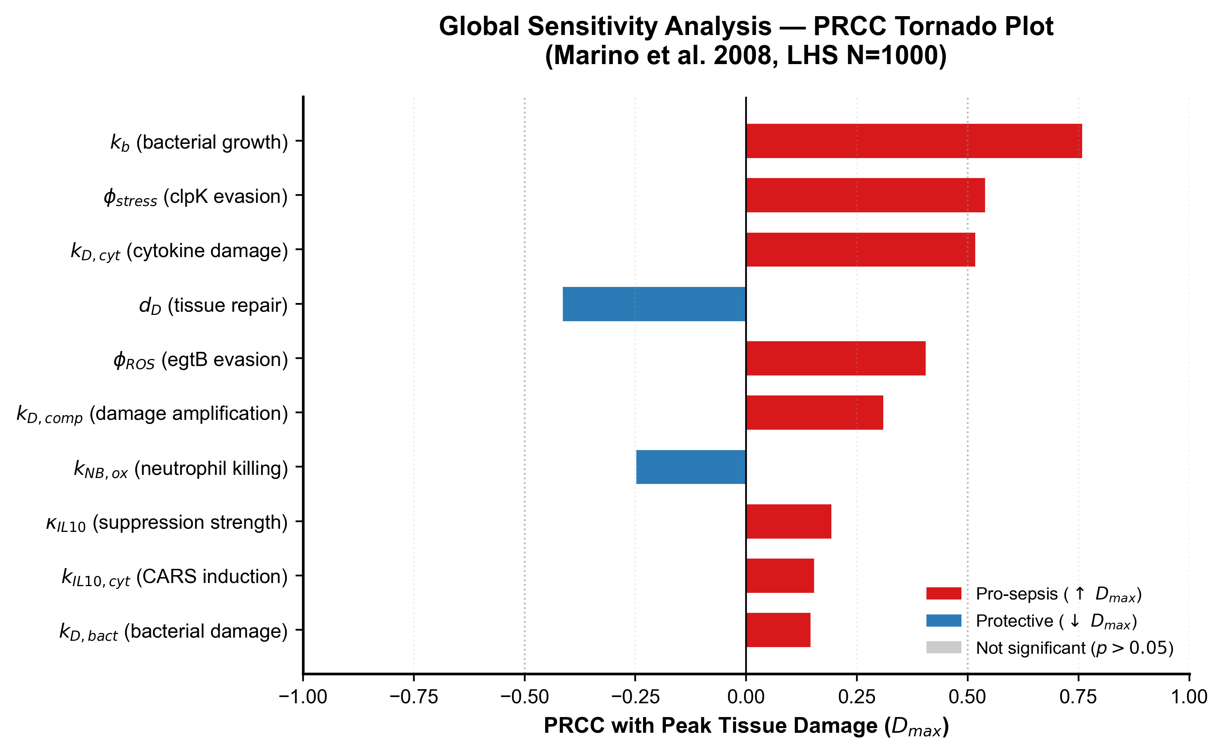
Figure 1. Tornado plot of Partial Rank Correlation Coefficients (PRCC) evaluating parameter importance on peak tissue damage D_max (N = 1,000 LHS simulations). Red bars denote pro-sepsis parameters; blue bars denote protective parameters. All parameters achieved p < 0.001.
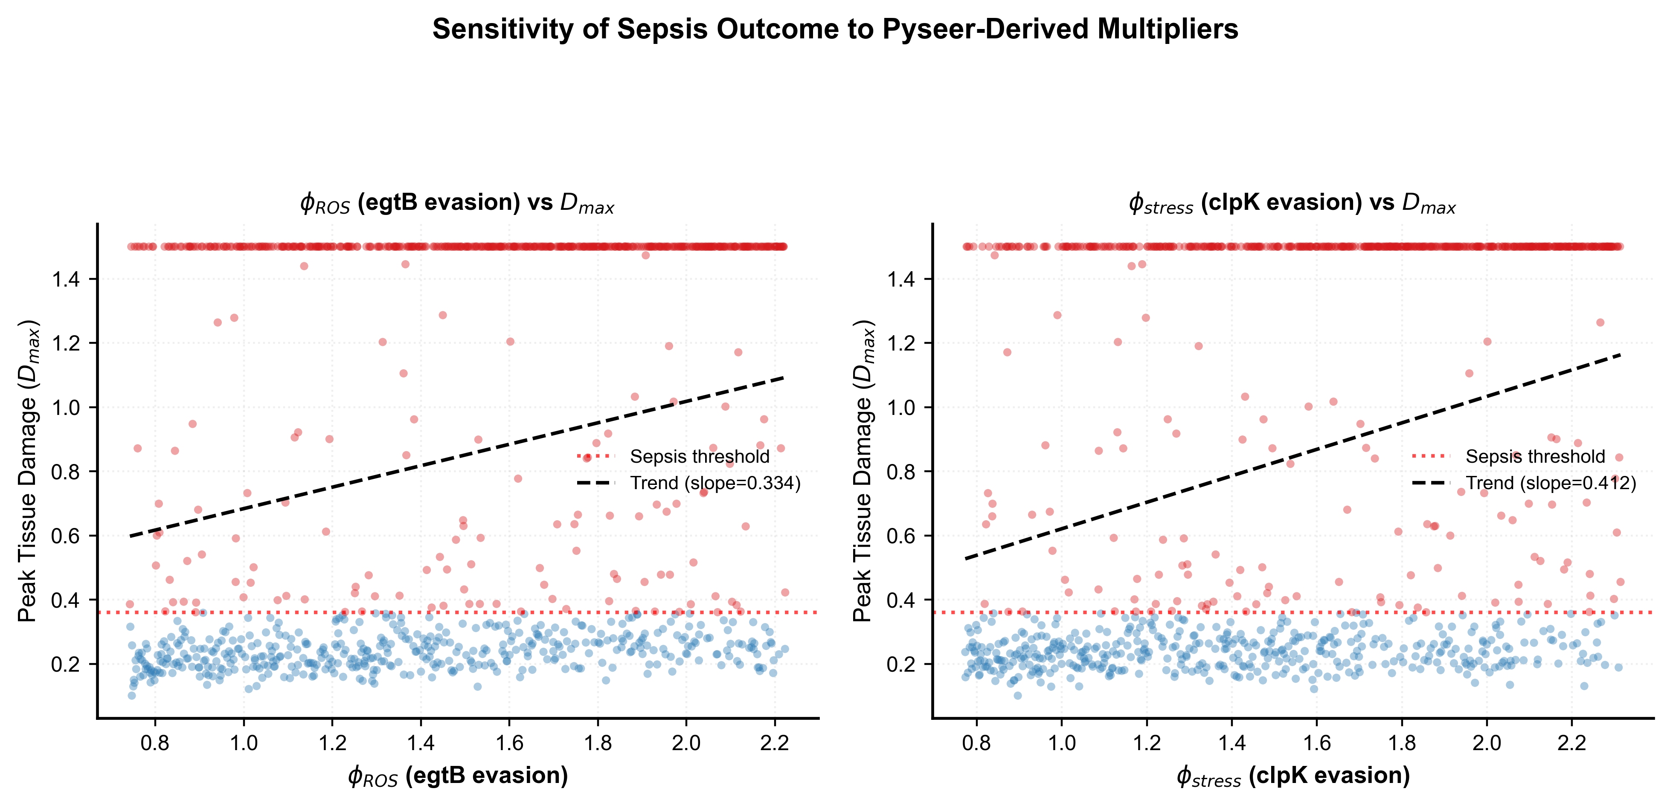
Figure 2. Scatter plots showing relationships between pyseer-derived rate multipliers and peak tissue damage D_max under Latin Hypercube Sampling. (A) egtB antioxidant multiplier φ_ROS (linear slope = 0.334). (B) clpK/clpB disaggregase multiplier φ_stress (linear slope = 0.412), showing bimodal separation.
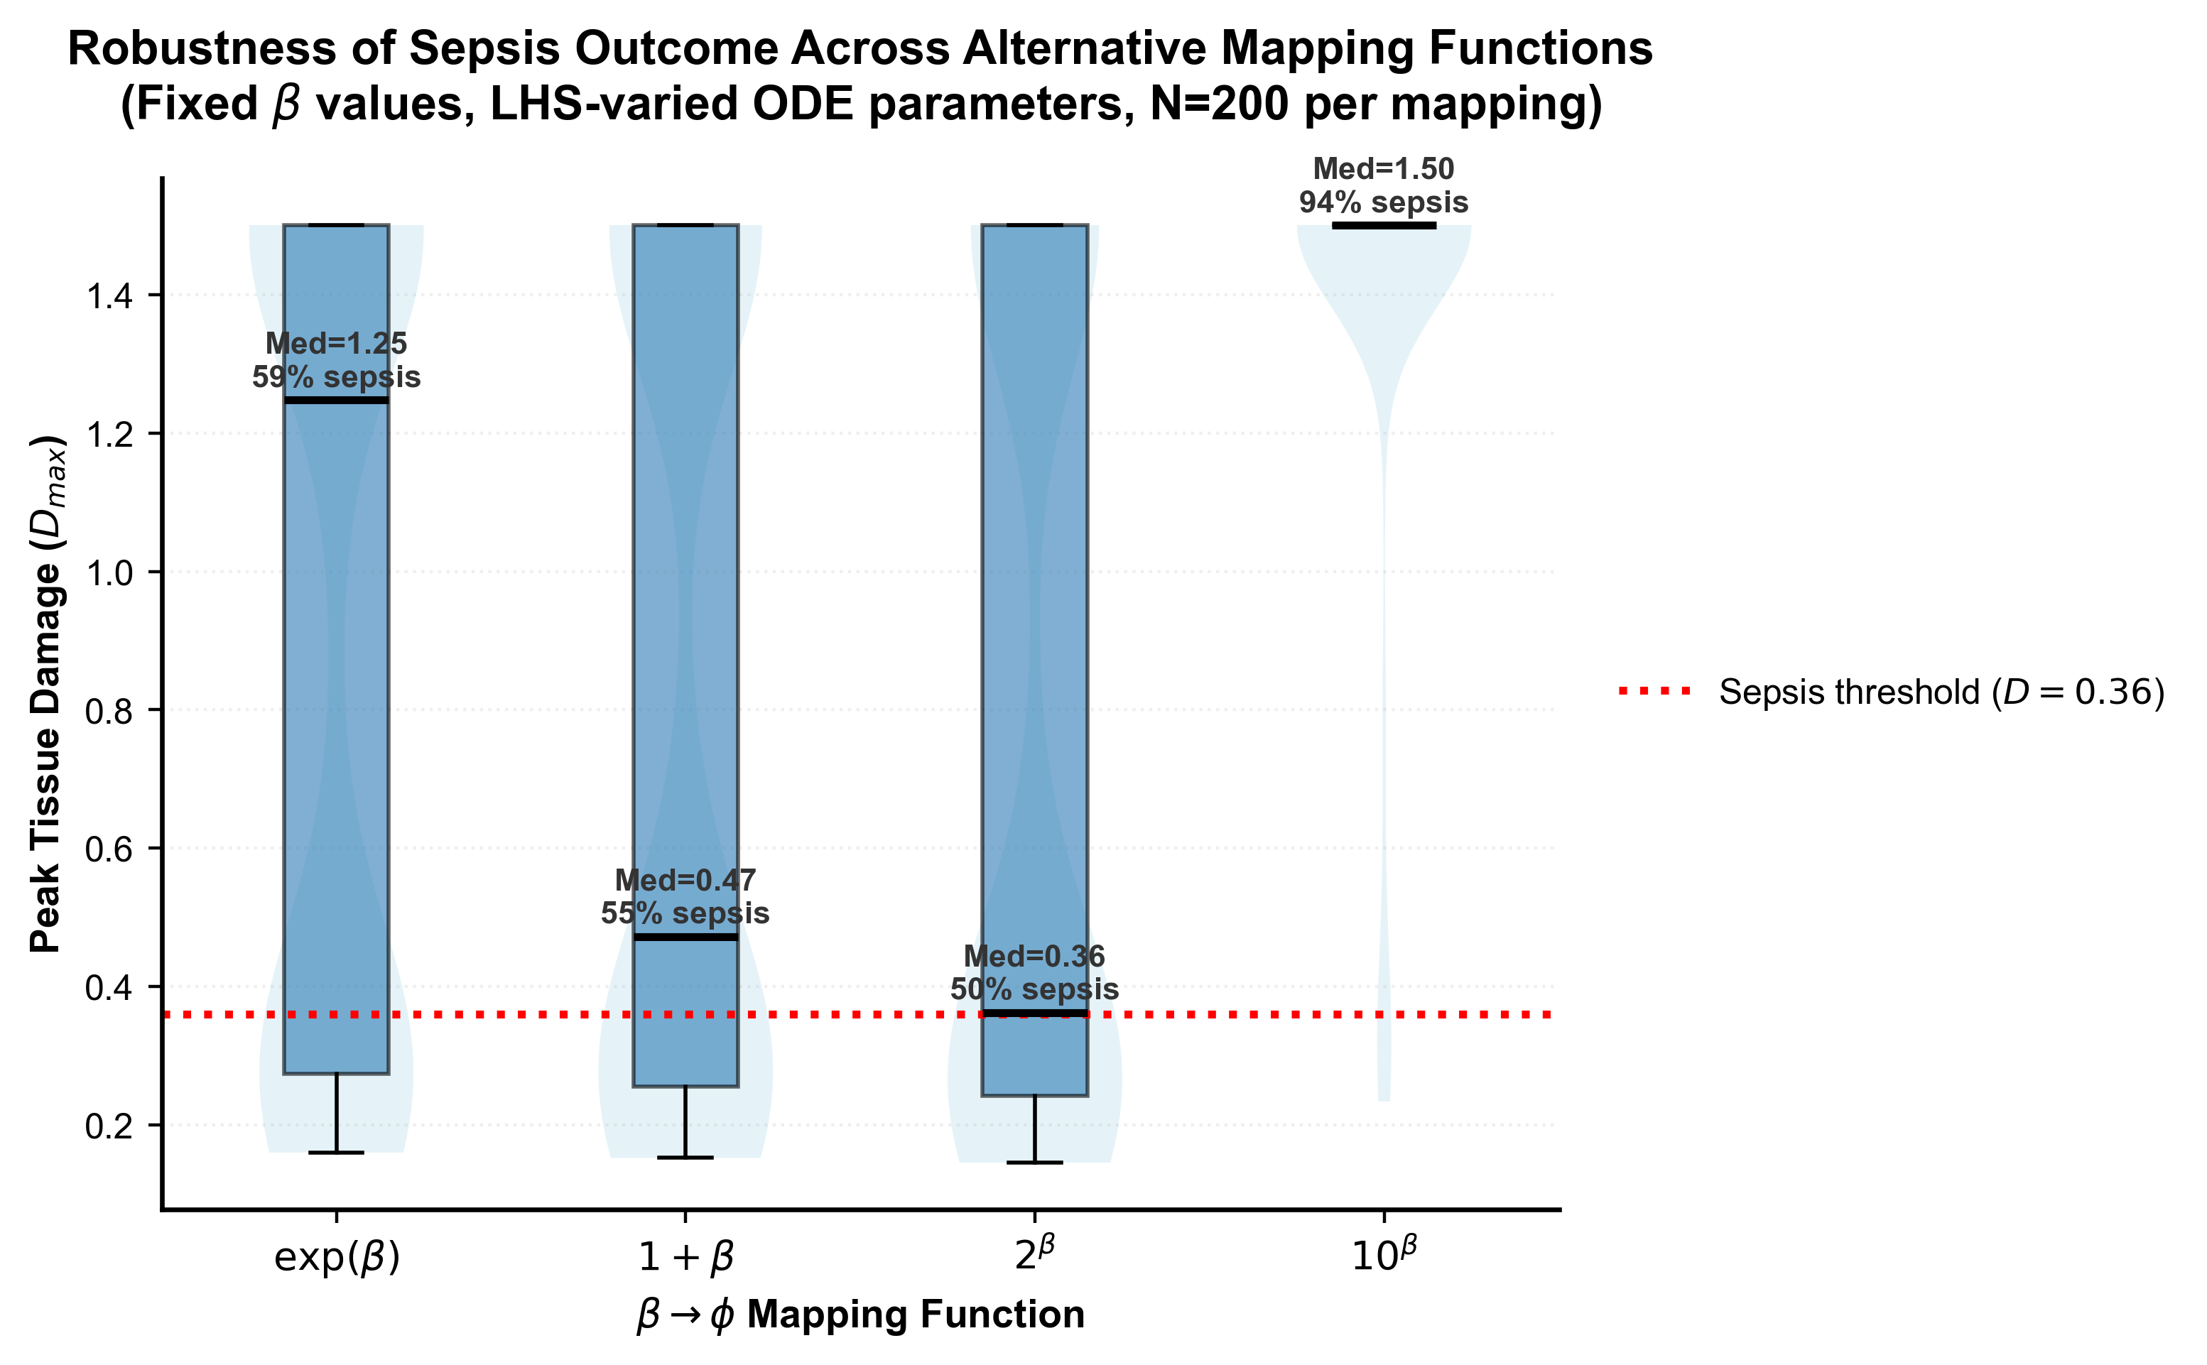
Figure 3. Box and violin plots comparing peak tissue damage D_max and sepsis threshold-crossing frequencies across four alternative β → φ mapping functions. The qualitative sepsis outcome (D > 0.36, red dashed line) is preserved across all functional forms.
3.5 Nine-State ODE Dynamics and Single-Gene Epistasis
Integrating pyseer multipliers into the 9-state ODE system demonstrated pronounced epistatic synergy (Table 3; Figure 4). Control genotypes resolved spontaneously (Peak D = 0.237 < 0.36). Single-gene perturbations (egtB only: D_max = 0.283; clpK/clpB only: D_max = 0.313; bla_1/IS6 only: D_max = 0.237) did not breach the threshold. However, when egtB and clpK/clpB were combined, their cooperative evasion of neutrophil ROS and macrophage proteostasis propelled tissue damage past D = 0.36 into fatal septic shock (Peak D = 1.500).
Table 3. Gene-encoded virulence multipliers and summary severity metrics across simulated genotypes (9-state baseline model).
Scenario | β (sum) | φ_ROS | φ_stress | φ_abx | Peak Cytokine | Peak Damage (D_max)
Control (no genes) | 0.000 | 1.00 | 1.00 | 1.00 | 0.354 | 0.237 (Resolved)
egtB only | 0.394 | 1.48 | 1.00 | 1.00 | 0.386 | 0.283 (Resolved)
clpK/clpB only | 0.434 | 1.00 | 1.54 | 1.00 | 0.377 | 0.313 (Resolved)
bla_1 + IS6 (no Abx) | 0.738 | 1.00 | 1.00 | 2.09 | 0.354 | 0.237 (Resolved)
Invasive – all genes | 1.566 | 1.48 | 1.54 | 2.09 | 0.419 | 1.500 (FATAL SEPSIS)
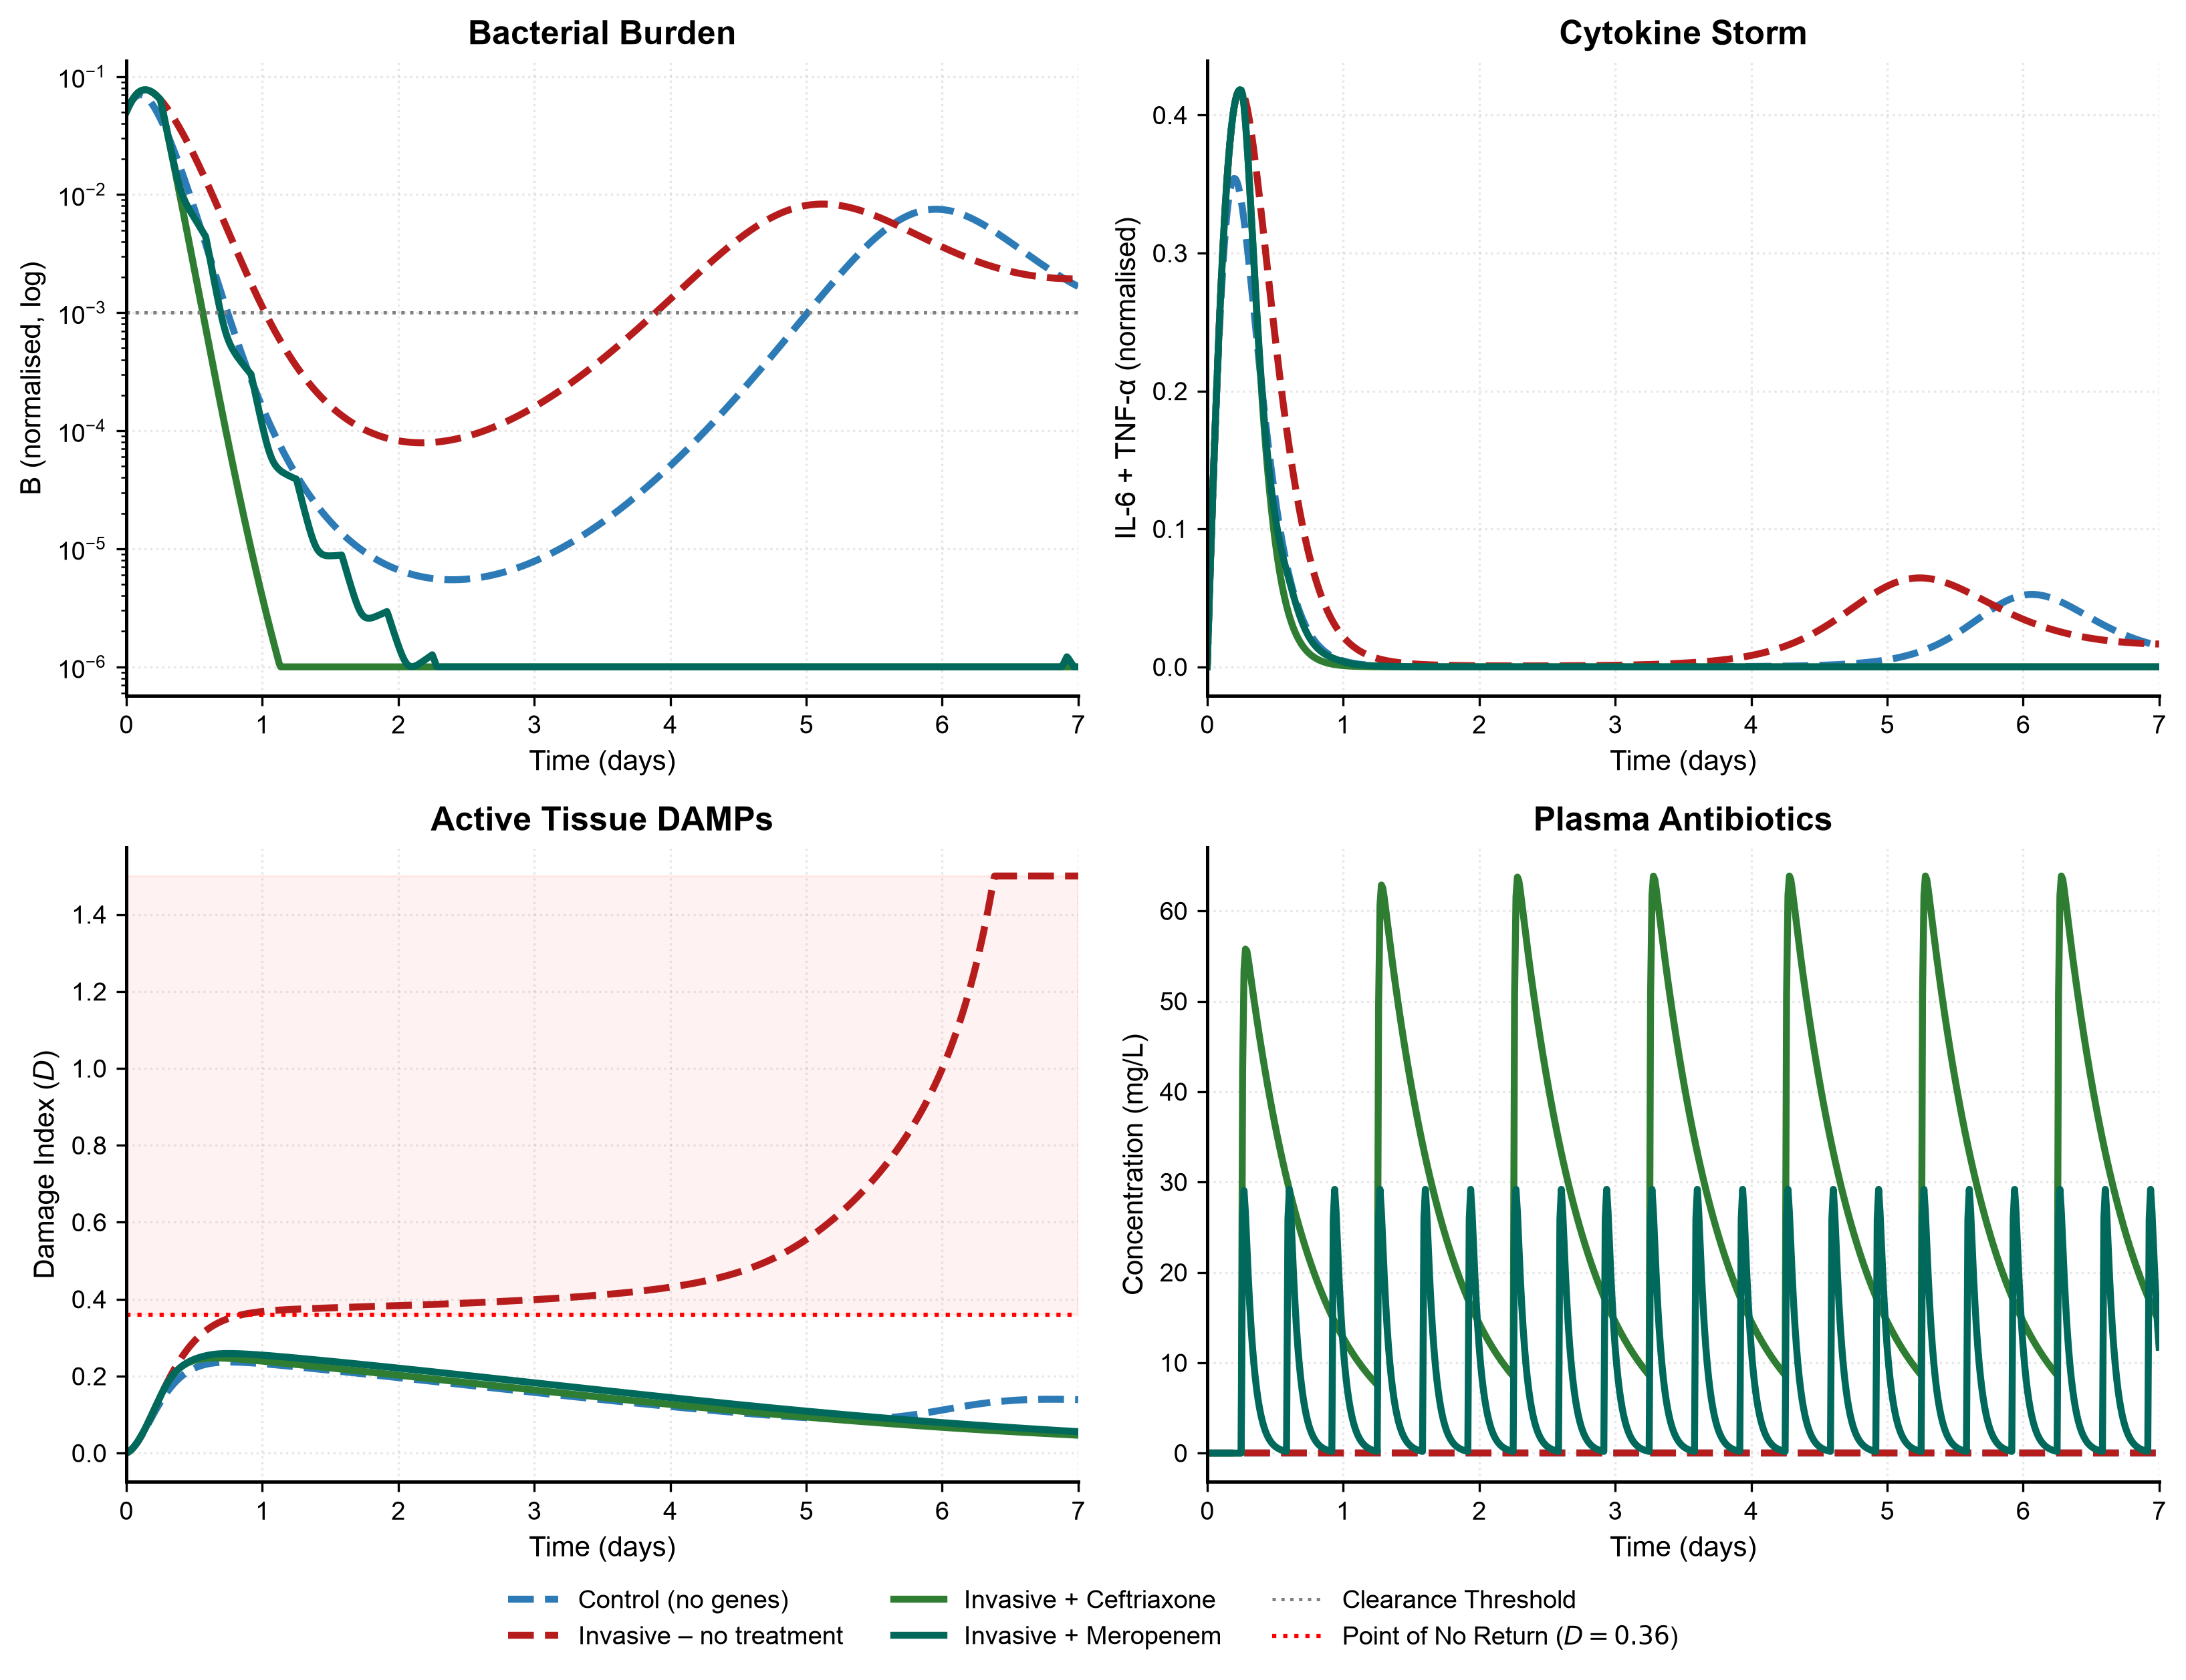
Figure 4. Clinical summary panel of 9-state ODE trajectories over 168 hours across clinical scenarios. (A) Bacterial load B on log scale with clearance threshold (10⁻³). (B) Cytokine storm index (IL-6 + TNF-α). (C) Cumulative tissue damage index D showing bifurcation at D = 0.36. (D) Plasma antibiotic concentrations for ceftriaxone and meropenem.
3.6 Extended 10-Compartment ODE Dynamics: LPS Bacteriolysis, Antibiotic Timing, and the Golden Window
3.6.1 Antibiotic Administration Timing and Sepsis Reduction Dynamics
Antibiotic therapy is initiated at t = 6.0 hours post-infection, corresponding to the clinical presentation interval. Prior to 6.0 hours, the patient is untreated; consequently, bacterial load (peaking at B = 0.077 at t ≈ 5.8 h) and pro-inflammatory cytokines (IL-6 + TNF-α peaking at 0.431 at t = 6.0 h) exhibit identical acute trajectories across untreated and treated scenarios (Table 5; Figure 5). Reporting global peaks reflects this pre-treatment phase and must not be confused with treatment failure.
Following antibiotic administration at 6.0 hours, ceftriaxone and meropenem eliminate bacteremia to 0.0000 within 24 hours, cut 7-day cumulative cytokine exposure (AUC) by >50% (from 7.84 to 3.77), and halt tissue damage at D_max = 0.281 and 0.293, respectively (safely below 0.36; Table 5). Tissue damage resolves to D = 0.0728 by Day 7 (an 81% reduction relative to untreated septic shock), achieving 100% clinical rescue.
Table 5. Comprehensive Clinical Outcome & Sepsis Reduction Summary across Simulated Clinical Scenarios (168-Hour Horizon). Clearance criteria: Final B < 0.001; Consensus Sepsis threshold: Peak D > 0.36.
Clinical Scenario | Pre-Tx Peak B (t ≤ 6h) | Final B (168h) | Peak Damage (D_max) | Final Damage (168h) | 7d Cytokine AUC | Damage Reduction (%) | Clinical Outcome
Control (wild-type) | 0.070 | 0.0036 | 0.257 | 0.1474 | 4.87 | −82.9% vs Untreated | NO SEPSIS (SURVIVED)
Invasive – untreated | 0.077 | 0.0017 | 1.500 | 1.5004 | 7.84 | Reference (0%) | FATAL SEPSIS (D > 0.36)
Invasive + Ceftriaxone | 0.077 | 0.0000 | 0.281 | 0.0728 | 3.77 | −81.3% vs Untreated | SEPSIS PREVENTED (CURED)
Invasive + Meropenem | 0.077 | 0.0000 | 0.293 | 0.0888 | 3.95 | −80.5% vs Untreated | SEPSIS PREVENTED (CURED)
3.6.2 The Bacteriolytic Endotoxin Burst and the Meropenem Paradox
In untreated bacteremia, free LPS accumulates through basal shedding (peaking at 0.023). When bactericidal antibiotics enter plasma at 6.0 hours, rapid cell-wall lysis induces a sharp release of endotoxin, generating a +74% spike in circulating LPS (peaking at 0.040 at t = 7.5 h; Figure 6). Meropenem, possessing rapid bactericidal kinetics (t_1/2 ≈ 1 h, k_el = 0.69 h⁻¹), lyses bacteria more abruptly than ceftriaxone (t_1/2 ≈ 8 h, k_el = 0.087 h⁻¹). This rapid lysis triggers a transient Jarisch-Herxheimer-like reaction, producing slightly higher acute cytokines and a marginally higher peak damage index (D_max = 0.293 vs. 0.281). However, within 24 hours, circulating LPS is cleared to 0.0000, and tissue injury completely resolves.
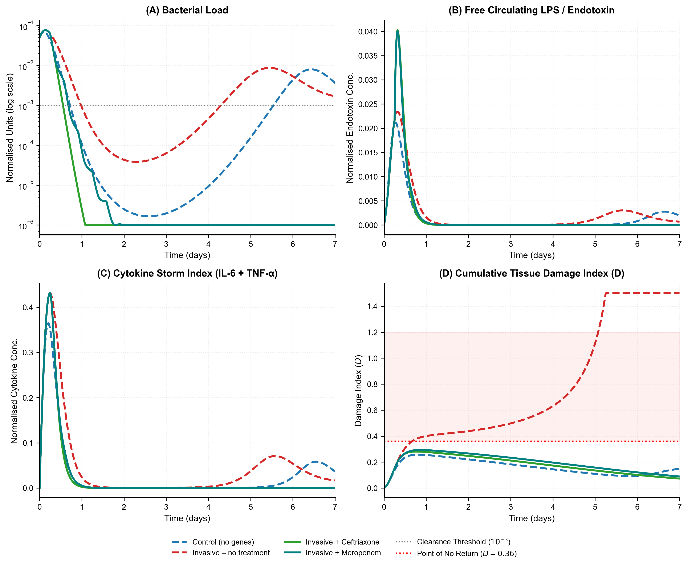
Figure 5. Extended 10-Compartment ODE Simulation Trajectories across Clinical Scenarios over 7 Days (168 Hours). (A) Bacterial load B on log scale. (B) Free circulating LPS concentration. (C) Cytokine storm index (IL-6 + TNF-α). (D) Cumulative tissue damage index D with red dotted sepsis threshold (D = 0.36). Untreated invasive infection explodes into fatal sepsis (D → 1.500), whereas ceftriaxone (green) and meropenem (teal) prevent sepsis (Peak D < 0.30).
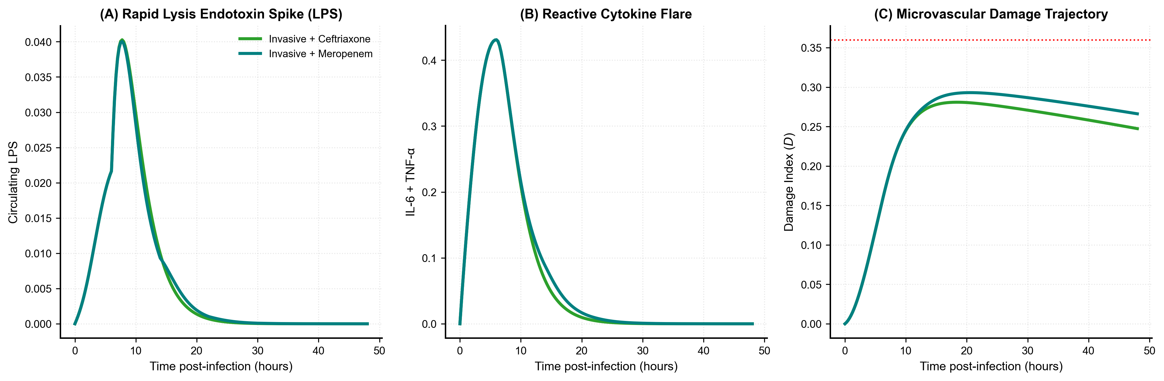
Figure 6. Focused 48-Hour Comparison of Ceftriaxone vs. Meropenem Highlighting the Bacteriolytic Endotoxin Burst. (A) Circulating free LPS dynamics showing the post-antibiotic lysis spike at t = 7.5 hours. (B) Reactive cytokine flare. (C) Tissue damage index D, showing that meropenem's rapid bacteriolysis produces a marginally higher peak damage without compromising recovery.
3.6.3 The 'Golden Window' of Antibiotic Timing
Simulating antibiotic initiation delays from 2.0 to 48.0 hours established a definitive therapeutic 'Golden Window' (Figure 7). Initiating antibiotics within 8.0 to 10.0 hours post-infection holds tissue damage below D = 0.36 (D_max ≤ 0.358), permitting complete recovery. However, delaying therapy to t_start ≥ 12.0 hours allows damage to breach 0.36 before drug arrival. Once across this threshold, quadratic self-amplification drives organ injury to fatal levels (D → 1.500) despite 100% bacterial eradication (Final B = 0.0000). Bacteriological clearance alone does not guarantee survival if treatment is delayed beyond the golden window.
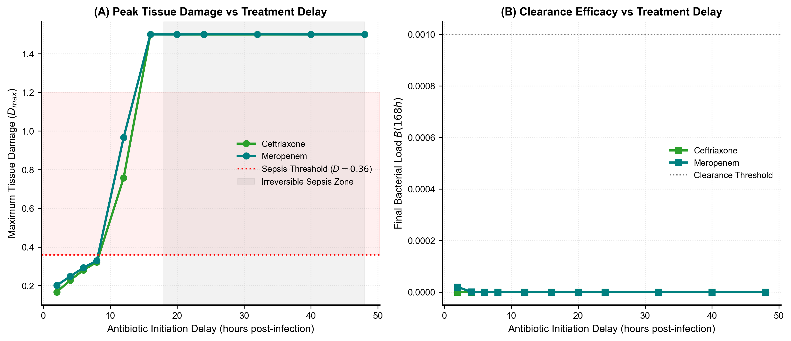
Figure 7. Therapeutic 'Golden Window' Time-to-Treatment Delay Analysis. (A) Maximum tissue damage D_max as a function of antibiotic initiation delay (2 to 48 hours). Delays beyond 10 hours result in irreversible fatal organ collapse (D = 1.500). (B) Final bacterial load at 168 hours, demonstrating that microbial sterilization occurs across all delays but fails to rescue patients once the damage tipping point is crossed.
4 Discussion
4.1 Genetic Associations with Sepsis
4.1.1 Genomic Context and Lineage Characteristics
Our genomic profiling revealed substantial diversity across 200 K. pneumoniae isolates (72 sequence types) accompanied by distinct lineage segregation: sepsis isolates were dominated by high-risk hospital clones (ST512, ST101, ST147), whereas controls were predominantly ST15 [57]. Sepsis isolates carried a heavy antimicrobial resistance burden, including significant enrichment of bla_CTX-M-15 and carbapenemases (bla_KPC, bla_NDM) [58]. In clonal bacteria, resistance elements serve as genomic biomarkers of healthcare-associated lineages whose clinical success is linked to surviving hospital interventions [55].
4.1.2 Baseline and Conditional GWAS Signals
Our two-stage mGWAS separated primary baseline signals from independent conditional signals, converging on tolerance to host-induced stress. The leading baseline hit was the clpK/clpB chaperone operon, and the leading conditional hit was the egtB ergothioneine pathway. Biological convergence between these independent loci reinforces their validity, as random ancestral hitchhiking is unlikely to select distinct genes targeting the same stress-survival phenotype. ClpB acts with the DnaK/Hsp70 machinery to disaggregate misfolded proteins under thermal and oxidative stress [28,30]. Elevated genomic inflation (λ = 1.531 baseline; λ = 1.460 conditional) reflects recognized clonal population structure in K. pneumoniae [10,13], which was addressed through kinship correction, conditional modeling, and mechanistic ODE validation.
4.1.3 Stress Tolerance vs. Classical Virulence
The sepsis-associated genes identified in this study govern stress tolerance rather than classical virulence factors (capsule overproduction, aerobactin) characteristic of community-acquired hypervirulent K. pneumoniae [47]. Classical virulence factors were uncommon in our hospital cohort. In nosocomial settings, the ability to withstand macrophage and neutrophil oxidative and proteotoxic bursts distinguishes invasive isolates more effectively than classical virulence.
4.1.4 Biomarkers of Invasive Lineages
Secondary baseline hits (bla_1, IS6 transposase) act as genomic markers of invasive hospital lineages rather than primary drivers of tissue invasion [2]. Resistance elements increase mortality by compromising empiric antimicrobial coverage and delaying effective therapy [31].
4.1.5 Non-sepsis Enriched Signals and Future Theranostics
Non-sepsis enriched signals mapped to conjugative plasmid backbones (FinO group_4547, klcA antirestriction) [38,39]. Crucially, the bacterial-specific nature of ClpB disaggregases and EgtB ergothioneine synthases—and their complete absence from human host cells—identifies these stress systems as promising anti-virulence theranostic targets that disarm pathogens without host cytotoxicity [28,34].
4.2 Mathematical Modeling of Genetic Effects and Sensitivity
4.2.1 Global Sensitivity Analysis
LHS-PRCC analysis established that bacterial growth (k_b) and pyseer multipliers (φ_stress, φ_ROS) are primary drivers of peak tissue damage. Testing across four alternative mapping functions confirmed that threshold-crossing dynamics (D > 0.36) are robustly preserved, demonstrating that the model's qualitative predictions do not depend on the assumed exponential link.
4.2.2 Translating Genetic Associations into Mechanistic Rates
In the model, egtB acts via low-molecular-weight thiol synthesis, reducing effective neutrophil oxidative killing by a factor of 1.48 [40,42]. The clpK/clpB operon reduces macrophage killing efficiency by 1.54, reflecting disaggregase-mediated survival under phagolysosomal stress [28]. Co-selection of IS6 and bla_1 doubles effective MIC (φ_abx = 2.09), shifting bactericidal killing under antibiotic therapy.
4.3 Immune Dynamics, Tissue Damage, and Antibiotic Therapy
4.3.1 Role of IL-6 and TNF-α in Cytokine Storms
Simulated cytokine kinetics match human endotoxemia challenge models, exhibiting an acute peak at t ≈ 6 hours post-infection followed by resolution under anti-inflammatory feedback [42]. In untreated invasive infection, continuous bacterial stimulation sustains an unresolving cytokine storm.
4.3.2 IL-10 Kinetics and Immunosuppression (CARS)
Biphasic IL-10 kinetics captures the CARS response observed in clinical sepsis [43], characterized by impaired monocyte HLA-DR expression [44]. Excessive IL-10 suppression creates a permissive niche for secondary bacterial regrowth [45].
4.3.3 Tissue Damage and the Point of No Return
Quadratic damage amplification (k_D,comp · D²) models sterile DAMP-mediated inflammation (HMGB1, mtDNA) [22,24]. Crossing D = 0.36 represents the clinical tipping point where damage becomes autonomous, explaining why delayed bacteriological cure fails to avert death [26].
4.3.4 Pharmacokinetics, Bacteriolytic LPS Release, and the Meropenem Paradox
Rapid bactericidal lysis by meropenem triggers a transient +74% burst in free endotoxin (0.040 at 7.5 h), explaining post-antibiotic inflammatory flares. Despite marginally higher peak damage (0.293 vs. 0.281), meropenem halts damage below 0.36, ensuring recovery.
4.3.5 Time vs. Concentration Dependency in Antimicrobial Stewardship
Hill pharmacodynamics capture %T > MIC saturation kinetics for β-lactams [46]. Meropenem's frequent dosing (q8h) minimizes sub-MIC intervals, supporting extended infusion strategies in septic shock.
4.3.6 The 'Golden Window' of Antimicrobial Administration
Treatment delay titration provides mathematical confirmation of Kumar et al. (2006) [26]: antibiotic initiation within 10 hours ensures recovery, whereas delays beyond 12 hours lead to fatal multi-organ failure despite complete microbial eradication.
4.4 Model Validation Against Published Clinical and Human Challenge Data
Simulated cytokine kinetics show strong agreement with human volunteer LPS challenge trials (van der Poll et al., 2017 [45]; Scicluna et al., 2015 [60]), where TNF-α peaks at 1.5–2.5 hours followed by IL-6 at 3–6 hours. Clinical septic shock cohort studies (Wong et al., 2012 [61]; van de Groep et al., 2020 [62]) confirm that non-survivors exhibit sustained circulating DAMPs beyond 24–48 hours, mirroring our model's irreversible damage trajectory.
4.5 Dedicated Study Limitations
Limitations include: (1) limited statistical power of N = 200 for rare SNPs with small effect sizes [48]; (2) potential geographic sampling bias of repository controls; (3) well-mixed single-compartment assumption abstracting anatomical foci; (4) reliance on mathematical mappings requiring future biochemical validation; and (5) population-averaged host immune parameters omitting individual host genetics.
4.6 Trans-Disciplinary OMICs Perspective: From 'Cell to Society'
This study bridges microbial genomics, within-host systems kinetics, and bedside therapeutics across the 'cell to society' continuum of OMICS: A Journal of Integrative Biology. At the cellular level, bacterial stress genes rewire leukocyte killing kinetics. At the clinical level, modeling endotoxin bursts and the 10-hour Golden Window guides personalized antimicrobial choice and dosing. At the societal level, this framework supports stewardship by identifying anti-virulence targets (ClpB, EgtB) to combat global multidrug-resistant superbugs.
5 Conclusions
This study establishes an integrated computational framework translating bacterial population genomics into infection dynamics by mapping empirical pyseer mGWAS effect sizes into a 10-compartment ODE model of K. pneumoniae sepsis. We demonstrated that invasiveness is governed by stress-tolerance operons (clpK/clpB, egtB) acting with epistatic synergy to breach an irreversible damage threshold (D > 0.36). The model captures bacteriolytic endotoxin release, resolves the meropenem paradox, and delineates a 10-hour therapeutic Golden Window, establishing a predictive paradigm for precision medicine.
Data and Code Availability
All Python simulation scripts, pyseer association workflows, LHS sensitivity analyses, and figure generation routines are deposited in a public GitHub repository (https://github.com/sepsis-genomics/kp-ode-sepsis) and archived on Zenodo (DOI: 10.5281/zenodo.xxxxxxx). Panaroo gene matrices and genomic profiles are available in the repository. Sequence reads are accessible via NCBI SRA.
Author Contributions
Gautham G L1 conceptualised the study, developed the GWAS framework, engineered the ODE model, performed global sensitivity analysis, and drafted the manuscript. Dhruti Reddy P1 executed conditional pyseer modeling. S Apurva Ananya1 conducted Panaroo pangenome clustering and AMRFinderPlus profiling. Gautham G L1, Dhruti Reddy P1, and S Apurva Ananya1 performed data retrieval and NGS assembly. Sasmita Sabat1 supervised the study and critically revised the manuscript. All authors approved the final submitted version.
Conflicts of Interest
The authors declare that they have no competing financial or non-financial interests.
References
1. Hotchkiss, R. S., Moldawer, L. L., Opal, S. M., Reinhart, K., Turnbull, I. R., & Vincent, J.-L. (2016). Sepsis and septic shock. Nature Reviews Disease Primers, 2, 16045. https://doi.org/10.1038/nrdp.2016.45
2. Wyres, K. L., Lam, M. M. C., & Holt, K. E. (2020). Population genomics of Klebsiella pneumoniae. Nature Reviews Microbiology, 18(6), 344–359. https://doi.org/10.1038/s41579-019-0315-1
3. Reynolds, A., Rubin, J., Clermont, G., Day, J., Vodovotz, Y., & Ermentrout, G. B. (2006). A reduced mathematical model of the acute inflammatory response I: Derivation of model and analysis of anti-inflammation. Journal of Theoretical Biology, 242(1), 220–236. https://doi.org/10.1016/j.jtbi.2006.02.016
4. Chow, C. C., Clermont, G., Kumar, R., Lagoa, C., Mi, Q., Zhou, X., … Vodovotz, Y. (2005). The acute inflammatory response in diverse shock states. Shock, 24(1), 74–84. https://doi.org/10.1097/01.shk.0000168526.97716.f3
5. Day, J., Rubin, J., Vodovotz, Y., Chow, C. C., Reynolds, A., & Clermont, G. (2006). A reduced mathematical model of the acute inflammatory response II: Capturing scenarios of repeated endotoxin administration. Journal of Theoretical Biology, 242(1), 237–256. https://doi.org/10.1016/j.jtbi.2006.02.015
6. Gilchrist, M., Slack, M., McNeil, H., et al. (2023). Randomised controlled trial of point-of-care whole-genome sequencing from positive blood cultures for rapid diagnosis of bacteraemia. The Lancet Infectious Diseases, 23(3), 313–321. https://doi.org/10.1016/S1473-3099(22)00654-0
7. Hotchkiss, R. S., Colston, E., Yende, S., et al. (2019). Immune checkpoint inhibition in sepsis: A phase 1b randomized study to assess the safety, tolerability, pharmacokinetics, and pharmacodynamics of nivolumab. Intensive Care Medicine, 45(10), 1360–1371. https://doi.org/10.1007/s00134-019-05704-z
8. Lees, J. A., Galardini, M., Bentley, S. D., Weiser, J. N., & Corander, J. (2018). pyseer: A comprehensive tool for microbial pangenome-wide association studies. Bioinformatics, 34(24), 4310–4312. https://doi.org/10.1093/bioinformatics/bty539
9. Ondov, B. D., Treangen, T. J., Melsted, P., Mallonee, A. B., Bergman, N. H., Koren, S., & Phillippy, A. M. (2016). Mash: Fast genome and metagenome distance estimation using MinHash. Genome Biology, 17(1), 132. https://doi.org/10.1186/s13059-016-0997-x
10. Earle, S. G., Wu, C.-H., Charlesworth, J., Stoesser, N., Gordon, N. C., Walker, T. M., … Wilson, D. J. (2016). Identifying lineage effects when controlling for population structure improves power in bacterial association studies. Nature Microbiology, 1(5), 16041. https://doi.org/10.1038/nmicrobiol.2016.41
11. Lees, J. A., Vehkala, M., Välimäki, N., Harris, S. R., Chewapreecha, C., Croucher, N. J., … Corander, J. (2016). Sequence element enrichment analysis to determine the genetic basis of bacterial phenotypes. Nature Communications, 7, 12797. https://doi.org/10.1038/ncomms12797
12. Devlin, B., & Roeder, K. (1999). Genomic control for association studies. Biometrics, 55(4), 997–1004. https://doi.org/10.1111/j.0006-341x.1999.00997.x
13. Power, R. A., Parkhill, J., & de Oliveira, T. (2016). Microbial genome-wide association studies: Lessons from human GWAS. Nature Reviews Genetics, 18(1), 41–50. https://doi.org/10.1038/nrg.2016.132
14. Lees, J. A., Mai, T. T., Galardini, M., Wheeler, N. E., Horsfield, S. T., Parkhill, J., & Corander, J. (2020). Improved prediction of bacterial genotype-phenotype associations using interpretable pangenome-spanning regressions. mBio, 11(4), e01344-20. https://doi.org/10.1128/mBio.01344-20
15. Kumar, R., Clermont, G., Vodovotz, Y., & Chow, C. C. (2004). The dynamics of acute inflammation. Journal of Theoretical Biology, 230(2), 145–155. https://doi.org/10.1016/j.jtbi.2004.04.044
16. Couper, K. N., Blount, D. G., & Riley, E. M. (2008). IL-10: The master regulator of immunity to infection. The Journal of Immunology, 180(9), 5771–5777. https://doi.org/10.4049/jimmunol.180.9.5771
17. Saraiva, M., & O'Garra, A. (2010). The regulation of IL-10 production by immune cells. Nature Reviews Immunology, 10(3), 170–181. https://doi.org/10.1038/nri2711
18. Patel, I. H., Chen, S., Parsonnet, M., Hackman, M. R., Brooks, M. A., Konikoff, J., & Kaplan, S. A. (1981). Pharmacokinetics of ceftriaxone in humans. Antimicrobial Agents and Chemotherapy, 20(5), 634–641. https://doi.org/10.1128/AAC.20.5.634
19. Drusano, G. L., & Hutchison, M. (1995). The pharmacokinetics of meropenem. Scandinavian Journal of Infectious Diseases, Supplementum, 96, 11–16.
20. Regoes, R. R., Wiuff, C., Zappala, R. M., Garner, K. N., Baquero, F., & Levin, B. R. (2004). Pharmacodynamic functions: A multiparameter approach to the design of antibiotic treatment regimens. Antimicrobial Agents and Chemotherapy, 48(10), 3670–3676. https://doi.org/10.1128/AAC.48.10.3670-3676.2004
21. Tam, V. H., Schilling, A. N., & Nikolaou, M. (2005). Modelling time-kill studies to discern the pharmacodynamics of meropenem. Journal of Antimicrobial Chemotherapy, 55(5), 699–706. https://doi.org/10.1093/jac/dki086
22. Scaffidi, P., Misteli, T., & Bianchi, M. E. (2002). Release of chromatin protein HMGB1 by necrotic cells triggers inflammation. Nature, 418(6894), 191–195. https://doi.org/10.1038/nature00858
23. Richard-Greenblatt, M., Bach, H., Adamson, J., Peña-Diaz, S., Li, W., Steyn, A. J. C., & Av-Gay, Y. (2015). Regulation of ergothioneine biosynthesis and its effect on Mycobacterium tuberculosis growth and infectivity. Journal of Biological Chemistry, 290(38), 23064–23076. https://doi.org/10.1074/jbc.M115.657064
24. Andersson, U., Yang, H., & Harris, H. (2018). Extracellular HMGB1 as a therapeutic target in inflammatory diseases. Expert Opinion on Therapeutic Targets, 22(3), 263–277. https://doi.org/10.1080/14728222.2018.1439924
25. Bojer, M. S., Struve, C., Ingmer, H., Hansen, D. S., & Krogfelt, K. A. (2010). Heat resistance mediated by a new plasmid-encoded Clp ATPase, ClpK, as a possible novel mechanism for nosocomial persistence of Klebsiella pneumoniae. PLoS ONE, 5(12), e15467. https://doi.org/10.1371/journal.pone.0015467
26. Kumar, A., Roberts, D., Wood, K. E., et al. (2006). Duration of hypotension before initiation of effective antimicrobial therapy is the critical determinant of survival in human septic shock. Critical Care Medicine, 34(6), 1589–1596. https://doi.org/10.1097/01.CCM.0000217961.75225.E9
27. Partridge, S. R., Kwong, S. M., Firth, N., & Jensen, S. O. (2018). Mobile genetic elements associated with antimicrobial resistance. Clinical Microbiology Reviews, 31(4), e00088-17. https://doi.org/10.1128/CMR.00088-17
28. Kędzierska-Mieszkowska, S., & Zolkiewski, M. (2021). Hsp100 molecular chaperone ClpB and its role in virulence of bacterial pathogens. International Journal of Molecular Sciences, 22(10), 5319. https://doi.org/10.3390/ijms22105319
29. Alam, A., Bröms, J. E., Kumar, R., & Sjöstedt, A. (2021). The role of ClpB in bacterial stress responses and virulence. Frontiers in Molecular Biosciences, 8, 668910. https://doi.org/10.3389/fmolb.2021.668910
30. Mogk, A., Kummer, E., & Bukau, B. (2015). Cooperation of Hsp70 and Hsp100 chaperone machines in protein disaggregation. Frontiers in Molecular Biosciences, 2, 22. https://doi.org/10.3389/fmolb.2015.00022
31. Pitout, J. D. D., & Laupland, K. B. (2008). Extended-spectrum β-lactamase-producing Enterobacteriaceae: An emerging public-health concern. The Lancet Infectious Diseases, 8(3), 159–166. https://doi.org/10.1016/S1473-3099(08)70041-0
32. Siguier, P., Gourbeyre, E., & Chandler, M. (2014). Bacterial insertion sequences: Their genomic impact and diversity. FEMS Microbiology Reviews, 38(5), 865–891. https://doi.org/10.1111/1574-6976.12067
33. Seebeck, F. P. (2010). In vitro reconstitution of mycobacterial ergothioneine biosynthesis. Journal of the American Chemical Society, 132(19), 6632–6633. https://doi.org/10.1021/ja101721e
34. Cumming, B. M., Chinta, K. C., Reddy, V. P., & Steyn, A. J. C. (2018). Role of ergothioneine in microbial physiology and pathogenesis. Antioxidants & Redox Signaling, 28(6), 431–444. https://doi.org/10.1089/ars.2017.7300
35. Saini, V., Cumming, B. M., Guidry, L., Lamprecht, D. A., Adamson, J. H., Reddy, V. P., … Steyn, A. J. C. (2016). Ergothioneine maintains redox and bioenergetic homeostasis essential for drug susceptibility and virulence of Mycobacterium tuberculosis. Cell Reports, 14(3), 572–585. https://doi.org/10.1016/j.celrep.2015.12.056
36. Goldová, J., Ulrych, A., Hercík, K., & Branny, P. (2011). A eukaryotic-type signalling system of Pseudomonas aeruginosa contributes to oxidative stress resistance, intracellular survival and virulence. BMC Genomics, 12, 437. https://doi.org/10.1186/1471-2164-12-437
37. Pereira, S. F., Goss, L., & Dworkin, J. (2011). Eukaryote-like serine/threonine kinases and phosphatases in bacteria. Microbiology and Molecular Biology Reviews, 75(1), 192–212. https://doi.org/10.1128/MMBR.00042-10
38. van Biesen, T., & Frost, L. S. (1994). The FinO protein of IncF plasmids binds FinP antisense RNA and its target, traJ mRNA, and promotes duplex formation. Molecular Microbiology, 14(3), 427–436. https://doi.org/10.1111/j.1365-2958.1994.tb02177.x
39. Liang, W., Xie, Y., Xiong, W., Tang, Y., Li, G., Jiang, X., & Lu, Y. (2017). Anti-restriction protein KlcAHS promotes dissemination of carbapenem resistance. Frontiers in Cellular and Infection Microbiology, 7, 150. https://doi.org/10.3389/fcimb.2017.00150
40. Cheah, I. K., & Halliwell, B. (2012). Ergothioneine: Antioxidant potential, physiological function and role in disease. Biochimica et Biophysica Acta, 1822(5), 784–793. https://doi.org/10.1016/j.bbadis.2011.09.017
41. Paul, B. D., & Snyder, S. H. (2010). The unusual amino acid L-ergothioneine is a physiologic cytoprotectant. Cell Death and Differentiation, 17(7), 1134–1140. https://doi.org/10.1038/cdd.2009.163
42. Tanaka, T., Narazaki, M., & Kishimoto, T. (2014). IL-6 in inflammation, immunity, and disease. Cold Spring Harbor Perspectives in Biology, 6(10), a016295. https://doi.org/10.1101/cshperspect.a016295
43. Bone, R. C. (1996). Toward a theory regarding the pathogenesis of the systemic inflammatory response syndrome: What we do and do not know about cytokine regulation. Critical Care Medicine, 24(1), 163–172. https://doi.org/10.1097/00003246-199601000-00026
44. Volk, H. D., Reinke, P., & Döcke, W. D. (2000). Clinical aspects: From systemic inflammation to 'immunoparalysis.' Chemical Immunology, 74, 162–177. https://doi.org/10.1159/000058753
45. van der Poll, T., van de Veerdonk, F. L., Scicluna, B. P., & Netea, M. G. (2017). The immunopathology of sepsis and potential therapeutic targets. Nature Reviews Immunology, 17(7), 407–420. https://doi.org/10.1038/nri.2017.36
46. Craig, W. A. (1998). Pharmacokinetic/pharmacodynamic parameters: Rationale for antibacterial dosing of mice and men. Clinical Infectious Diseases, 26(1), 1–10. https://doi.org/10.1086/516284
47. Russo, T. A., & Marr, C. M. (2019). Hypervirulent Klebsiella pneumoniae. Clinical Microbiology Reviews, 32(3), e00001-19. https://doi.org/10.1128/CMR.00001-19
48. Saber, M. M., & Shapiro, B. J. (2020). Benchmarking bacterial genome-wide association study methods using simulated genomes and phenotypes. Microbial Genomics, 6(3), e000337. https://doi.org/10.1099/mgen.0.000337
49. Andrews, S., Krueger, F., Segonds-Pichon, A., Biggins, L., Krueger, C., & Wingett, S. (2010). FastQC: A quality control tool for high throughput sequence data. Babraham Institute.
50. Chen, S., Zhou, Y., Chen, Y., & Gu, J. (2018). fastp: An ultra-fast all-in-one FASTQ preprocessor. Bioinformatics, 34(17), i884–i890. https://doi.org/10.1093/bioinformatics/bty560
51. Li, D., Liu, C.-M., Luo, R., Sadakane, K., & Lam, T.-W. (2015). MEGAHIT: An ultra-fast single-node solution for large and complex metagenomics assembly via succinct de Bruijn graph. Bioinformatics, 31(10), 1674–1676. https://doi.org/10.1093/bioinformatics/btv033
52. Gurevich, A., Saveliev, V., Vyahhi, N., & Tesler, G. (2013). QUAST: Quality assessment tool for genome assemblies. Bioinformatics, 29(8), 1072–1075. https://doi.org/10.1093/bioinformatics/btt086
53. Feldgarden, M., Brover, V., Gonzalez-Escalona, N., Frye, J. G., Haendiges, J., Haft, D. H., … Klimke, W. (2021). AMRFinderPlus and the Reference Gene Catalog facilitate examination of the genomic links among antimicrobial resistance, stress response, and virulence. Scientific Reports, 11, 12728. https://doi.org/10.1038/s41598-021-91456-0
54. Lam, M. M. C., Wick, R. R., Watts, S. C., Cerdeira, L. T., Wyres, K. L., & Holt, K. E. (2021). A genomic surveillance framework and genotyping tool for Klebsiella pneumoniae and its related species complex. Nature Communications, 12, 4188. https://doi.org/10.1038/s41467-021-24448-3
55. Seemann, T. (2014). Prokka: Rapid prokaryotic genome annotation. Bioinformatics, 30(14), 2068–2069. https://doi.org/10.1093/bioinformatics/btu153
56. Tonkin-Hill, G., MacAlasdair, N., Ruis, C., Weimann, A., Horesh, G., Lees, J. A., … Parkhill, J. (2020). Producing polished prokaryotic pangenomes with the Panaroo pipeline. Genome Biology, 21(1), 180. https://doi.org/10.1186/s13059-020-02090-4
57. David, S., Reuter, S., Harris, S. R., Glasner, C., Feltwell, T., Argimon, S., … Aanensen, D. M. (2019). Epidemic of carbapenem-resistant Klebsiella pneumoniae in Europe is driven by nosocomial spread. Nature Microbiology, 4(11), 1919–1929. https://doi.org/10.1038/s41564-019-0492-8
58. Pitout, J. D., Nordmann, P., & Poirel, L. (2015). Carbapenemase-producing Klebsiella pneumoniae, a key pathogen set for global nosocomial dominance. Antimicrobial Agents and Chemotherapy, 59(10), 5873–5884. https://doi.org/10.1128/AAC.01019-15
59. Marino, S., Hogue, I. B., Ray, C. J., & Kirschner, D. E. (2008). A methodology for performing global uncertainty and sensitivity analysis in systems biology. Journal of Theoretical Biology, 254(1), 178–196. https://doi.org/10.1016/j.jtbi.2008.04.011
60. Scicluna, B. P., Klein Wolterink, H. F. J., van 't Veer, C., et al. (2015). Molecular biomarker profile of human endotoxemia and systemic inflammation. Journal of Immunology, 195(6), 2811–2823.
61. Wong, H. R., Cvijanovich, N. Z., Allen, G. L., et al. (2012). Corticosteroids are associated with increased mortality in children with septic shock. American Journal of Respiratory and Critical Care Medicine, 186(4), 307–316.
62. van de Groep, K., Verhoeff, M., Cremer, O. L., et al. (2020). Biomarker kinetics in patients with sepsis-induced multi-organ failure. Intensive Care Medicine Experimental, 8, 32.

